HOME FOR ELDERLY,
Drniš

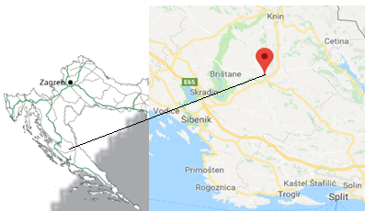
LOCATION
Drniš area is part of Šibenik-Knin County located in the north-central part of Dalmatia known as Dalmatian Hinterland (Croatian: Dalmatinska Zagora). The name Zagora means "behind hills", referring the fact that it is the part of Dalmatia that is not coastal. The biggest city in the county is Šibenik, which also serves as county seat. Drniš area encompasses of Town of Drniš and Municipalities of Ružić, Promina and Unešić.
Although the area belongs to underdeveloped part of the Republic of Croatia, it is attractive for life and permanent stay due to the many factors out of which stand out good traffic connections, natural beauties (proximity of the Adriatic coast-30 km, 2 national parks: “Krka” and “Kornati” as well as Nature Park Vransko jezero and Čikola canyon) and sub-Mediterranean climate, with mild winters and hot summers. The area is easy to reach by any means of transportation: by car (via the A1 motorway with several local roads, as an alternative), by train (railway lines from Zagreb to Split passing through Drniš) and by plane (airport Split -54 km and Airport Zadar -102 km).

The long tradition of Drniš area is preserved in lifestyle and local gastronomy. One of its trademarks is traditional Drniš prosciutto, with unique quality due to the specific microclimate conditions of the area. Besides Drniš offers a large number of cultural events ( Shrove Tuesday Carnival, The Passion Evenings, Easter Breakfast, Drniš Summer Evenings, Choral Festival of Spiritual Music "Jubilate Deo", International Prosciutto Festival, Cheese Festival, Miljevci Amenities) and possibilities for various recreational activities such as bike trails, walking and hiking trails along the Čikola and Krka canyons and the mountain Promina.

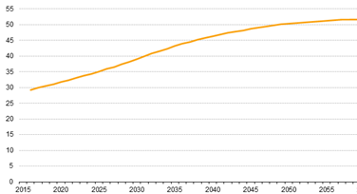
PROJECT DESCRIPTION Projected old-age dependency ratio, EU-28, 2016-80 (%)
Aging of the population is a long-term trend present for the last few decades in Europe with constant increase of population aged 65 and over in all EU Member States.
As result of this trend the demand for homes for the elderly and disabled persons is increasing in Europe including Croatia which is in the high stage of demographic transition. According to the 2011 census, Šibenik-Knin County has one of the oldest population in Croatia with an average age of 44.1 years.
The aging index is 146.1 and indicates the
aging population thus additionally emphasizing
the importance of investment in homes for the elderly and the infirm.
Currently the planned investment is the only one of this kind in the area of Drniš which includes municipalities of Unešić (aging Index 319.7), Promina (aging Index 263,8) and Ružić (aging Index 190,3).
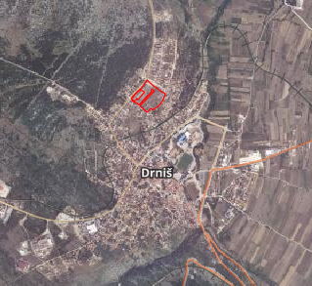
The town of Drniš owns a lend plot of 5652 m², according to the current urban plan foreseen for the construction of high-end home for elderly for 97 users. The building will consist of basement, ground floor with management and 3 floors with ambulance, and accommodation units (single and double rooms). Located in residential area all necessary infrastructure is in place (public electricity, water supply, sewerage systems, waste water purifier).
As an incentive measure, City of Drniš is ready to offer the future investor an exemption from the municipal contribution payment in the amount of 3 EUR/m³.

TRANSACTION MODEL
The project value is estimated at 6.1 million EUR and offers flexible investment model: land sale, right to build, lease of the land or strategic partnership .
CONTACTS
Grad Drniš, Ivana Sučić
e-mail: ivana.sucic@drnis.hr
+385/22/888830, 888845

Project holder: City of Drniš
Address: 22320 Drniš, Trg kralja Tomislava 1
Web: https://drnis.hr

Dijagram: ec.europa.eu/eurostat/data/database
Slika - ili geoportal (gornja) ili ova dolje:
